**Name: Christopher Holmes**

**30 points**

**Objectives**

* Create an E-R diagram of the JRJ application database using the MySQL workbench reverse engineering tool
* Reverse engineering refers to taking an existing database and creating an E-R diagram
* Modify the E-R diagram for new application requirements
* Forward engineering is creating SQL DDL (create table statements) from an E-R diagram.
* Create and execute SQL create table statements for a new design

**Reading**

* Read chapter 10 in murach textbook on design, normalization and use MySQL Workbench for design.

**Database Setup**

* If you do not have the database schmea JRJ from prior weeks, download the file jrj_create_table.sql. This contains an sql script for creating schmea JRJ, tables and loading the tables with small amount of data.

**What to submit for this lab?**

**Edit this lab document and save as PDF using Assign5_<your last name>.pdf as the file name. Then submit to iLearn assignment 5.**

**Part 1. Reverse Engineering of the JRJ database**

Open MySQL Workbench connect to database server

Choose the menu option **Database 🡪 Reverse Engineer** and follow the prompts to select the tables in the JRJ schema.

When complete you should have an E-R diagram that looks like this

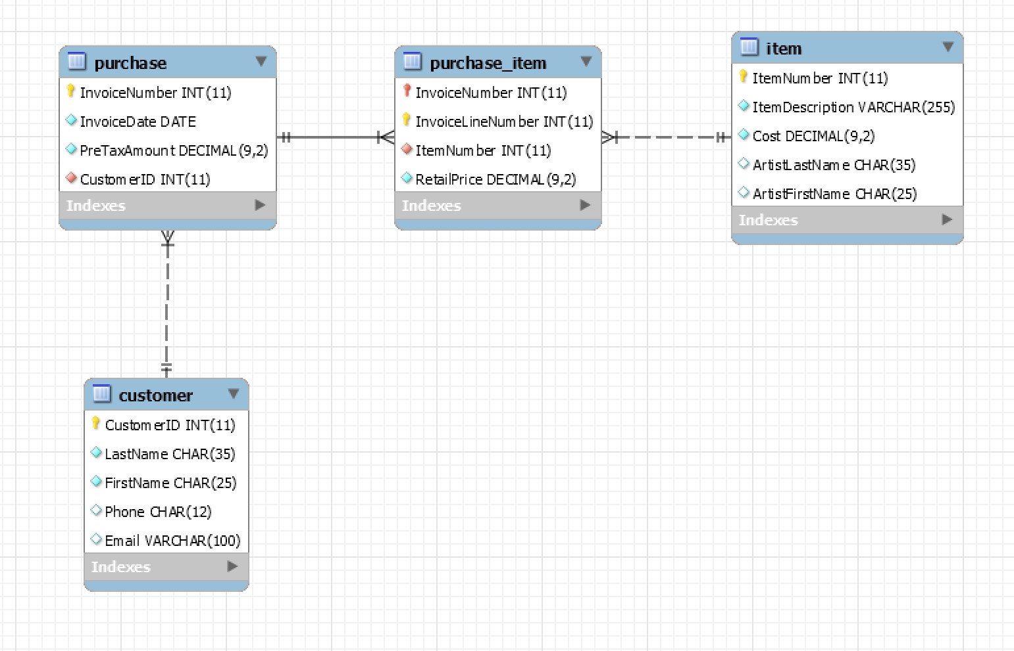

JRJ stands for James River Jewelry. It is a fictitious jewelry store. Items for sale are listed in the Item table. Profile information for customers is in the Customer table. When customers make a purchase, a row in the Purchase describes the overall purchase (the date of transaction, total amount). The items purchased are recorded in the Purchase_Item table and include the price paid for this item.

Based on your reading of the E-R diagram, answer the following questions:

1. What is the key of the Customer entity?

-CustomerID is the key of the Customer entity

1. What is the key of the Purchase entity?

-InvoiceNumber is the key of the Purchase entity

1. Describe the relationship between Customer and Purchase?
   1. Is it 1-to-1, 1-to-Many, Many-to-Many?
      1. The relationship is 1-to-many. Each customer can make many purchases, but each purchase can only be made by one customer
   2. Is the relationship mandatory?
      1. Yes the relationship is mandatory
   3. Is a customer entity required to have at least one purchase?
      1. A customer entity is required to have a related purchase entity
   4. Is a purchase entity required to have a related customer entity?
      1. A purchase entity is required to have a related customer entity

1. What is the key of purchase_item entity?
   1. InvoiceLineNumber

1. Describe the relationship between Purchase and purchase_item?
   1. It is a 1-to-Many relationship. Each purchase can have one or more items purchased.

1. What is the key of Item entity?
   1. ItemNumber

1. Describe the relationship between purchase_item and Item entities?
   1. It is a Many-to-1 relationship

**Part 2: Modify JRJ diagram for new requirements**

The Jewelry store wants to expand its database application to include

* tracking of artists and styles
* which customers are interested in artists and styles.
* The store wants to establish an award program.
* When a customer purchases 10 pieces of jewelry, the 11th purchase will receive a discount equal to 50% of the average of the 10 prior purchases.
* The store also wants to track how often and which pieces of jewelry are purchased using this award program.

There will new entities for Style and Artist. Customers can register their interest in particular styles and artists and so there are relationships between Customer entity and Style entity and between Customer and Artist entities.

Modify the E-R diagram for these new entities and relationships.

To implement the awards the customer entity will need attributes to track the number of purchases and the total of these purchases. When the number of purchases reaches 10, the next purchase will receive a discount equal to 50% of the average purchase with is 0.50*(total/10). And the number of purchases and total will be reset to 0.

Modify the E-R diagram for these new attributes for the Customer entity.

Modify the Purchase_Item entity to include a new field for AwardDiscount which is the discount (if any) given for this purchase.

1. Is the modified database design normalized? If yes, how do you know. If no, explain why you chose an unnormalized design.

-I attempted to do a normalized database by creating a table for style and artist. This was linked using ID’s so that each table only had the relative information to that table.

1. Give an example of a design for Style and Artist data that is NOT normalized. What are some of the problems related to using designs that are not normalized?

* Storing the style and artist information in the customer table would be a not normalized design. This would cause problems when you want to delete an artist or a style. You would have to delete them from the customer table, and this can cause issues. Having them separate allows for additions and deletions on either of the tables, and it won’t effect the other one.

1. If you were the database designer for this project, how would go about validating this new data model?

* The thing I would want to check is does this meet all the requirements that were laid out by the business. If the database doesn’t do what the business needs it to do, then it isn’t a good model and would need to be reevaluated. You want to make sure that you are following a set of naming standards setout before starting the project, that way you can make sure that everyone is speaking the same language throughout the entire project. If one person thinks something means one thing, and the model uses that in a totally different way, then you are going to have problems.

1. Save your design model for later.

**Part 3: Generate and review the SQL create statements**

* Menu 🡪 File 🡪 Export 🡪 Forward Engineer
* This will create an sql script. Save this script to a file.
* Review the sql script.

1. What is the definition of the column Purchase_Item.AwardDiscount? Should the definition include the keywords NOT NULL? What do the keywords NOT NULL mean?

* The NOT NULL keyword means that the value null is not allowed to be included in that field. This will be enforced by not allowing any null values stored into this field. The Purchase_Item.AwardDiscount should include the keyword NOT NULL. You are only going to get a discount on items if you purchased 10, so the other times you will not have a discount and you need to be able to account for this.

1. Can a customer register an interest in an artist if that artist does NOT exist in the Artist table? Explain why or why not?

-No a customer cannot register an interest in an artist that does not exist. There currently is no way for the database to automatically add the artist if they don’t exist. The front end application would need to handle the addition of the artist if they don’t already exist.

1. If customers 1, 4 and 9 are interested in the artist Juan Pablo. These same customers are also interested in another artist Theresa Christi. How are these relationships represented in the database?

* These relationships are represented as a many to one relationship. There can be many customers that are interested in the specific artist.

1. JRJ jewelry has a certain item for sale, but the artist is unknown. Do you see any problem when inserting the row for this item into the Item table?

-I see this being a problem because we are now tracking which styles each person buys, and since the artist is unknown, we won’t be able to track which artist the person purchased since this is tied into the style and artist.